**EXP10**

**Fibonacchi Series of N**

**CODE:**

#include <stdio.h>

void fibonacchi(){

int i, n;

int t1 = 0, t2 = 1;

int nextTerm = t1 + t2;

printf("Enter the number of terms: ");

scanf("%d", &n);

printf("Fibonacci Series: %d, %d, ", t1, t2);

for (i = 3; i <= n; ++i) {

printf("%d, ", nextTerm);

t1 = t2;

t2 = nextTerm;

nextTerm = t1 + t2;

}

}

int main() {

fibonacchi();

return 0;

}

**OUTPUT:**

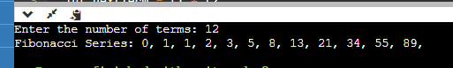

**Matrix**

CODE:

#include <stdio.h>

void matrix(){

int i, j, m, n;

int matrix[10][20];

printf("Enter number of rows : ");

scanf("%d", &m);

printf("Enter number of columns : ");

scanf("%d", &n);

for (i = 0; i < m; i++)

{

for (j = 0; j < n; j++)

{

printf("Enter data in [%d][%d]: ", i, j);

scanf("%d", &matrix[i][j]);

}

}

for (i = 0; i < m; i++)

{

for (j = 0; j < n; j++)

{

printf("%d\t", matrix[i][j]);

}

printf("\n");

}

}

int main()

{

matrix();

return 0;

}

OUTPUT:

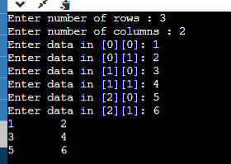

int nextTerm = t1 + t2;

printf("Enter the number of terms: ");

scanf("%d", &n);

printf("Fibonacci Series: %d, %d, ", t1, t2);

for (i = 3; i <= n; ++i)

{

printf("%d, ", nextTerm);

t1 = t2;

t2 = nextTerm;

nextTerm = t1 + t2;

}

}

int main()

{

fibonacchi();

return 0;

}

**OUTPUT:**

